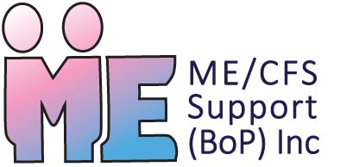
ME/CFS Support (BoP) Inc.
Registered Charity No. CC20874

Our New Initiative “Towards Wellness Workshops”
Thank you for showing an interest in ME/CFS Support (BoP) and our new ‘Towards Wellness Workshops’ series that we plan to run throughout the year. Our Fundraising initiative is called ‘Towards Wellness ME’.
ME Support has created and launched this pilot workshop series for people with ME/CFS to assist their recovery process and to give sufferer’s hope and knowledge to assist them to move forward in their lives. The overall response from participants of this programme has been incredible. The programme has been described as
'life-changing' by some who have struggled with this condition for decades.
We want to find supporters who are able to give $1 or $2 per week by Automatic Payment on a weekly or a monthly basis, to enable us to fund this life changing series of Towards Wellness Workshops and also the
follow-on workshops that reinforce the key learnings. We aim to support participants to apply this knowledge into their everyday lives, PLUS train participants to run their own future groups safely to keep the momentum of their recovery moving forward.
We will keep in contact with those who have completed the Towards Wellness programme and seek evaluations of our participants’ health and feedback on the course material, to continue to create a strong and robust programme prototype that other areas of New Zealand may also use in the future. We plan to inform GPs and Health Professionals in the Bay of Plenty about the workshops so they can be confident to refer complex cases such as ME/CFS and Fibromyalgia.
To support our vision we need assistance from our community to continue the delivery of this programme.
At just $1 or $2 a week you will be able to contribute to this exciting new community initiative.
To set up an automatic payment, you can do so via your bank or internet banking facility.
Our Bank: Kiwibank A/C No. 38-9014-0140507-00
Reference: Your name (so we know who is giving) & TWW ME Support (BoP)
Please email us your full name and address so we can provide you with a tax receipt after each tax year so that you can receive your 30% tax rebate.
Alternatively, you may be able to organise your donations to be made via Payroll Giving and your 30% tax rebate is automatically processed each pay day.
Thank you for supporting the Towards Wellness Workshops that are making a very real difference in the lives of individuals and their families. By working together as a collaborative team, possibilities become realities, and illness can become wellness, so THANK YOU.

